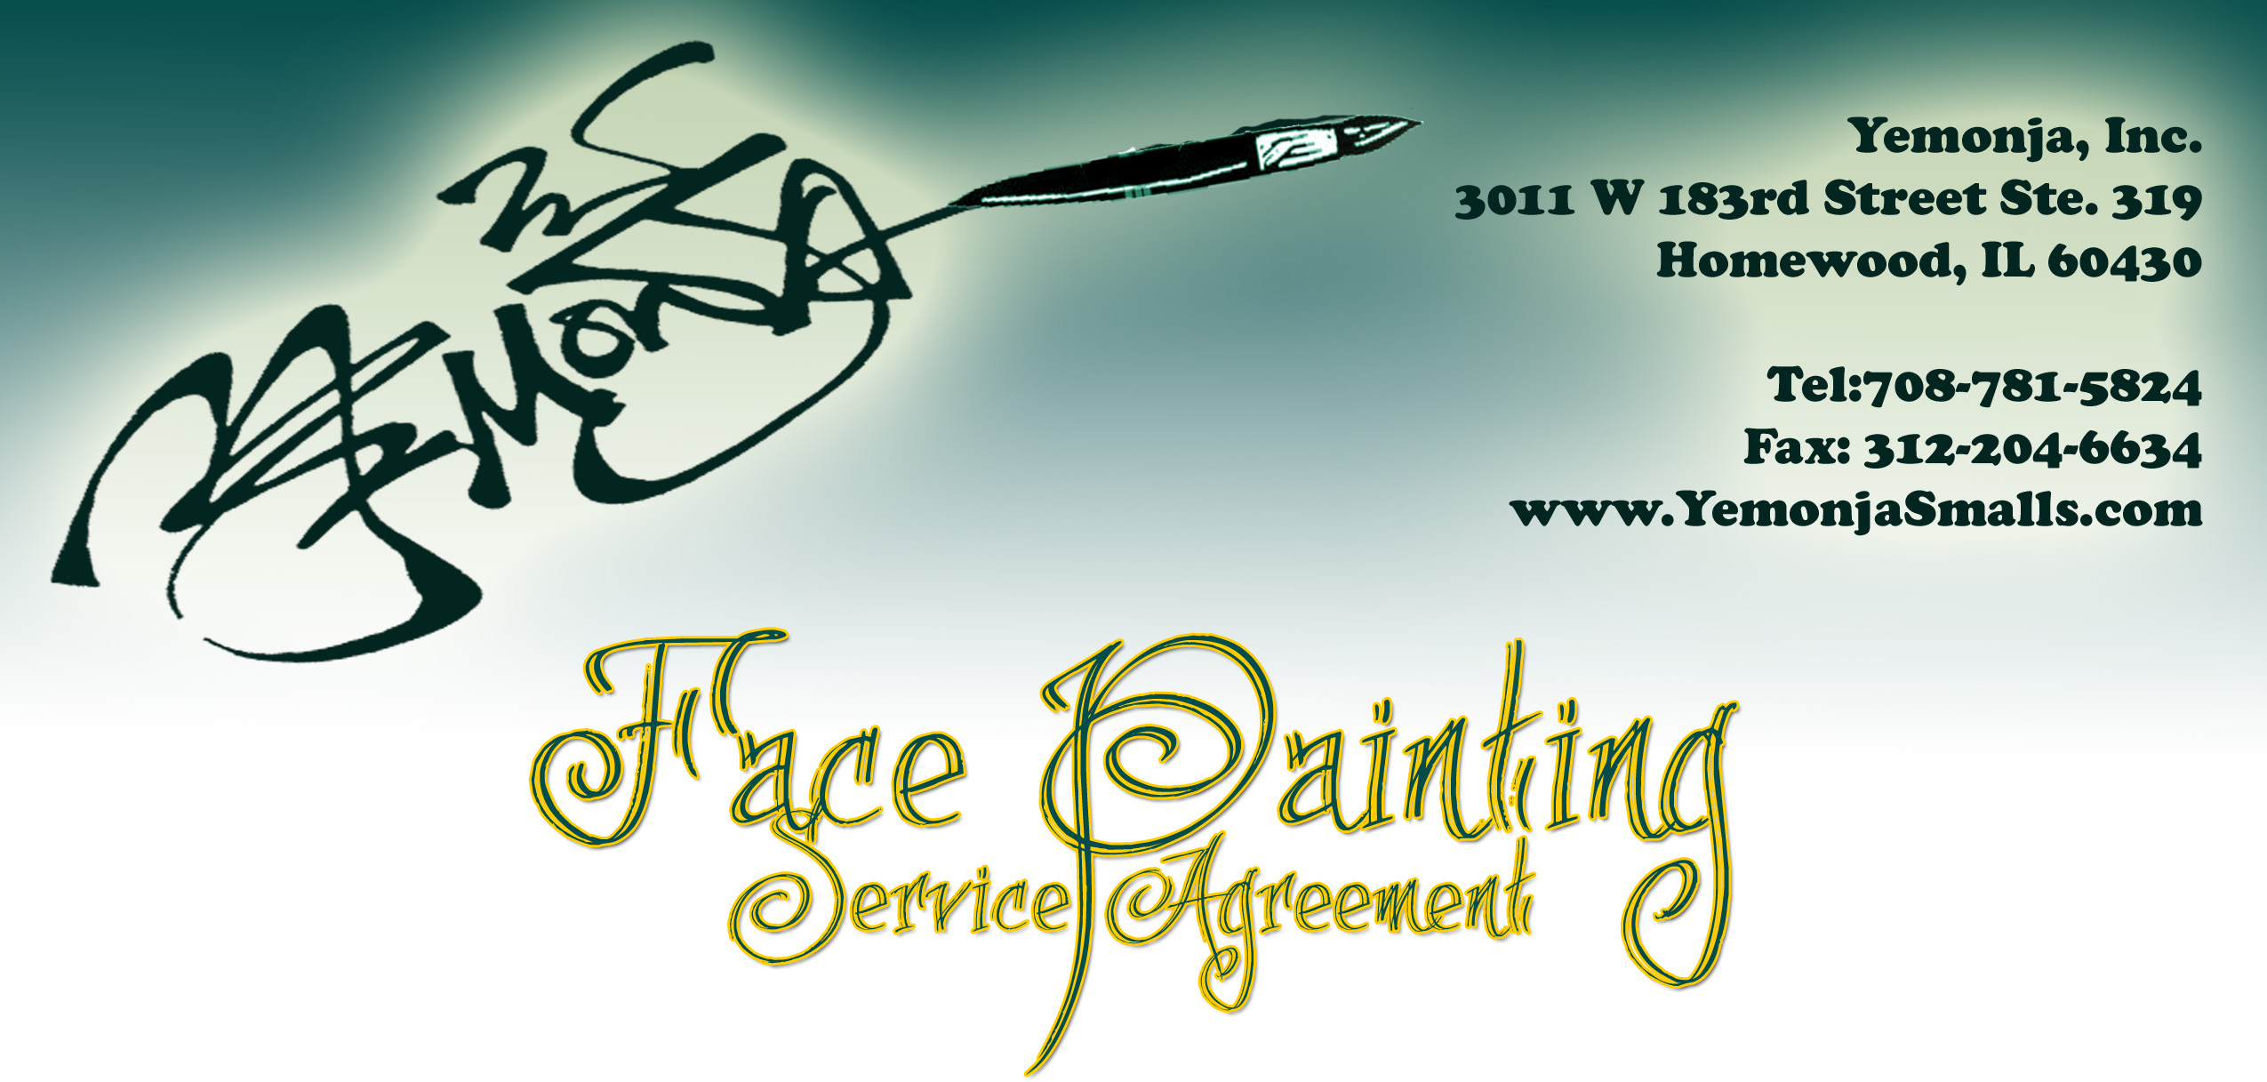
This agreement is a legal contract between Yemonja, Inc. and _____________(herein after referred to as “Client”), for face painting services.

EVENT DETAILS

Date:________________________________ Email:_______________________________________

Client’s name:_________________________ Contact Person:_______________________________
-OR-
Company name:_______________________

Street:_______________________________ City:__________________________ Zip:__________

Business/Cell/Contact Phone:______________________________________

Fax number:____________________________________________________

Date of Event:________________________ Start Time:_______________ End Time:_________

Celebrant’s name (If applicable)________________________________________________________

Event Indoors / Outdoors / Both (Circle one) Approximate number of guests:____________

Event description (please include themes, colors and special activities:_________________________

_________________________________________________________________________________

Address of Event Location________ Check if address is the same as above

Street:________________________________________City:_________________ Zip:___________

Additional details or directions regarding location (Gated community, landmarks, parking situation,etc.)

___________________________________________________________________________________

Liability Statement:
- Although I only used FDA approved and safe for skin products, the artist is not liable for allergic reactions to makeup products/paints. It is the parent’s responsibility to notify the artist if their child has sensitive skin. For safety reasons, the artist will not paint on children under 2 years old.
- For sanitary reasons, artist will not paint anyone who appears to be sick or be suffering from: cold sores, conjunctivitis, any infection skin condition, eczema, inflamed acne, or open wounds. Artist will use reasonable care, but is not responsible for damage to clothes or property.
- Artist will not supervise children. Their behavior and safety is the Parents/Hosts’ responsibility. Artist cannot watch other children while she is painting.
- Artist has the right to refuse service to anyone. Artist has the right to refused to paint offensive material (gang tattoos, symbols/pictures with double meaning; (offensiveness to be determined solely by the artist) and an alternative design will be offered.
- Artist has the right to cease painting and leave premises due to extreme or hazardous weather conditions (thunderstorms, tornado watches, etc).
Exclusivity:
Client agrees that Yemonja, Inc. will be the sole provider of face painting services at said event. In the situations where volunteers are in use, they will be best utilized for line management, not for face painting. No face painting materials will be provided to any other persons for use.

Photo Consent and Release:
By having your guests’ faces painted and photographed, permission is thereby granted to use images for the painter’s portfolio, marketing materials such as print, website or other publications. No names are revealed. If for any reason, you do not agree, please notify the artist immediately. Privacy will be respected.

Cancellation/Rescheduling and Event changes:
- Should Client for any reason cancel or postpone, there will be a cancellation fee of $25 for each date cancelled or postponed
- Client acknowledges that this retainer is non-refundable, non-transferable, and cannot be split amongst multiple events. The client may apply the retainer to a future booking no more than 6 months from the original date of the event if the original date must be reschedule. Due to scheduling, the client further understands that their first choice of rescheduling dates may not be available.
- Client agree to notify Yemonja, Inc. immediately upon any changes to the date/time/location of any other pertinent information regarding said event, and understands that failure to notify will not void this agreement, may result in the forfeiture of the retainer fee.

Returned checks:
There will be a $35 fee for returned checks plus the amount of the check.

Parking/Face Painting Location:
- Parking must be provided for the artist closest to the event location, so that equipment may be unloaded. The Client will reimburse the artist for any parking fees, or provide parking validation. Provide details on where the artist may unload.
- Please do not place artist near event speakers or stages as she will need to converse/communicate with guests.
- Keep in mind that long lines may form while guests wait their turn. Please place artist in a place that can accommodate lines.

Amount of Faces Painted:
- Artist typically paint 10-15 faces per hour depending on the designs-which may not include “full faces”. Yemonja, Inc. cannot guarantee that all guests will be painted and may have to cut off the waiting line 15 minutes prior to our end time, in order to proceed to next appointment.
- Client acknowledges that Yemonja, Inc. has estimated the number of guests and this estimate is based on many factors, including some that may be out of the control of the painter.

Fee Details:
Time artist begins:____________ Finish time:_______________
(artist will arrive 15-30 minutes early for set up; hourly fee does not include set up or clean up time.)

Overtime:
Any time beyond the contracted amount will cost $25 per 15 minute increment.

Total face painting hours: Quoted at $_____.00 x ___hours…………………………………… $______________

Travel fee (if outside of Matteson, Country Club Hills, Tinley Park, Orland Park, and neighboring locale ( $0.35 per mile)
$______________

Total amount for services………………………………………………………………………………………...…..$_____________

Discount (military 10%)……………………………………………………………………………………………..…$_____________

*Retainer to secure date (non-refundable) $50…………………………………………………….$__-50.00______

BALANCE TO BE PAID ON THE DAY OF THE EVENT TO FACE PAINTER………………………………………………………………………………….………$____________

Client agrees to pay full amount even if Client actual uses artist for less time than booked
If event is located at a park, we will not be able to accept checks on the day of event, only cash.
If you valued our services gratuity for the artist is not expected but always appreciated.

Please initial one:

__________Client requests that, if painter’s schedule allows, Yemonja complete ALL guest desiring painting and agrees to pay an additional fee in half hour increments, until all are served.

__________Client requests that artist promptly closes the line and cuts off services at the original ending time agreed upon. Client understands that this may not accommodate all guests desiring to be painted.

If you choose to pay via check, please make check payable to Yemonja, Inc.

To pay the retainer fee to secure your date with credit card:

- Please visit www.YemonjaSmalls.com and click the face painting link to the right. Click booking and you will be directed to paypal, a secure site with no financial information revealed. It is here that you will pay your retainer fee.
- Your event will not be secured until the retained has been received, or other arrangements have been made. This is a non-refundable retainer, should you cancel services. You may also mail a check along with the service agreement; however the date will not be secure until funds have cleared.
- Please send us an email at Customerservice@yemonjasmalls.com to let us know that you have sent the service agreement. Please fax it to 312-204-6634.

I have read, understand and accept the above Terms & Liability Statement, and the conditions of this agreement. I accept the details of the agreement in its entirety.

Client Signature________________________________________________________

Title:________________________________________ Date:____________________

Please sign and date the agreement and mail or fax it back to Yemonja, Inc immediately. Your event day (s) will only be held for three (3) days without the signed agreement.

Thank you for selected Yemonja, Inc. for your event!

